SPRINT 3

Check the Project:

WOKWI SIMULATOR LINK : <https://wokwi.com/projects/348396627523797588>

WEB UI LINK : <https://node-red-dashboard059.eu-gb.mybluemix.net/fire>

Results:

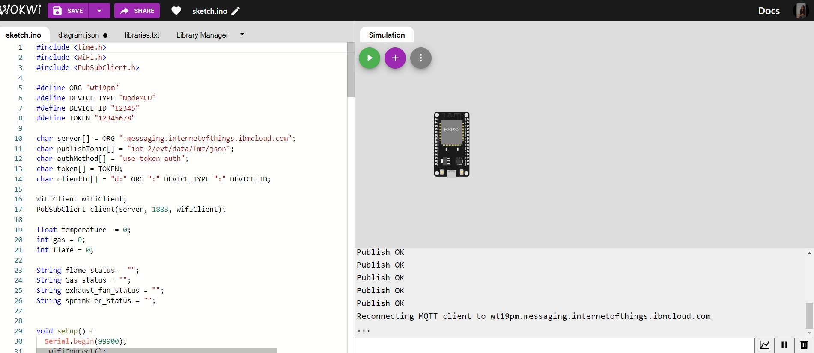

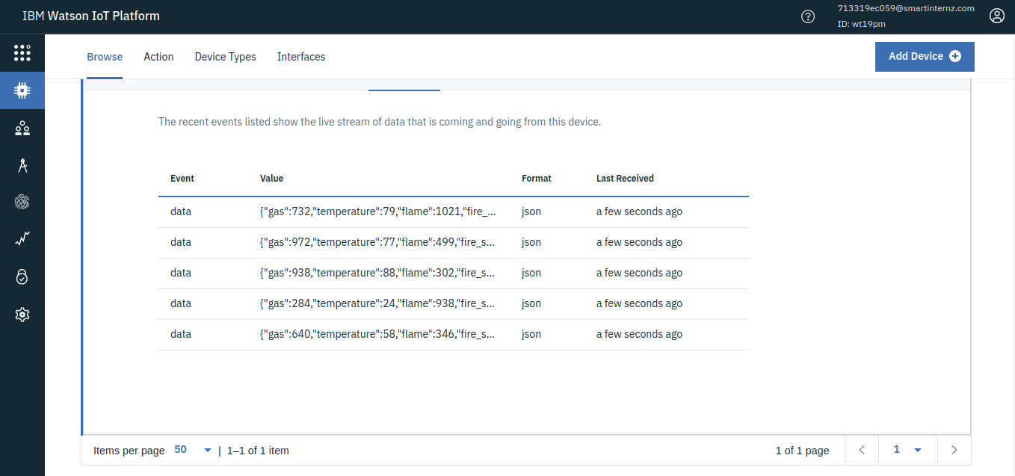

TRANSFERRING DATA FROM IBM WATSON INTO NODE-RED:

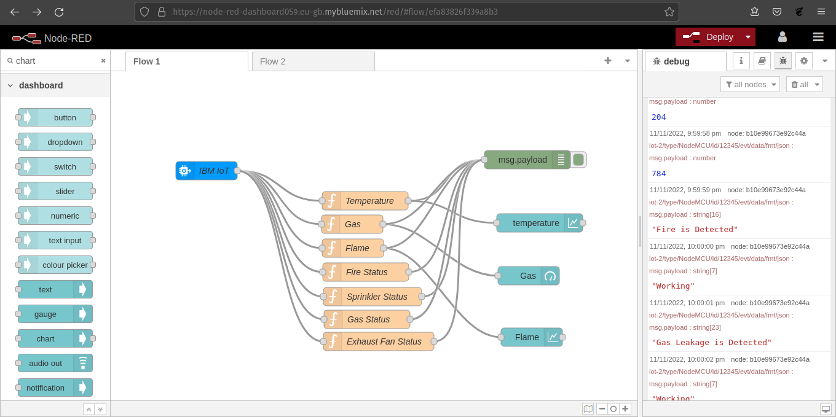

NODE-RED DASHBOARD:

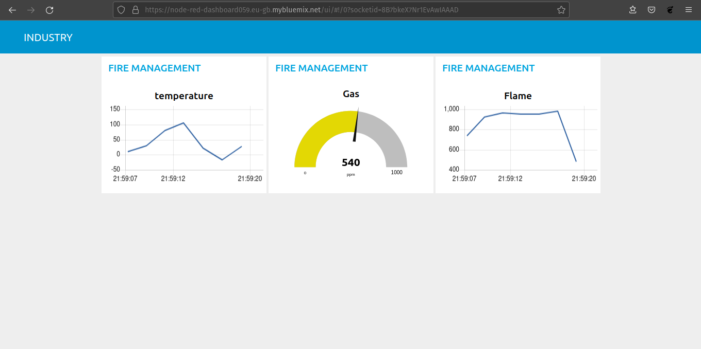

TRANSFERRING DATA FROM NODE-RED INTO WEB PAGE USING WEB SOCKET:

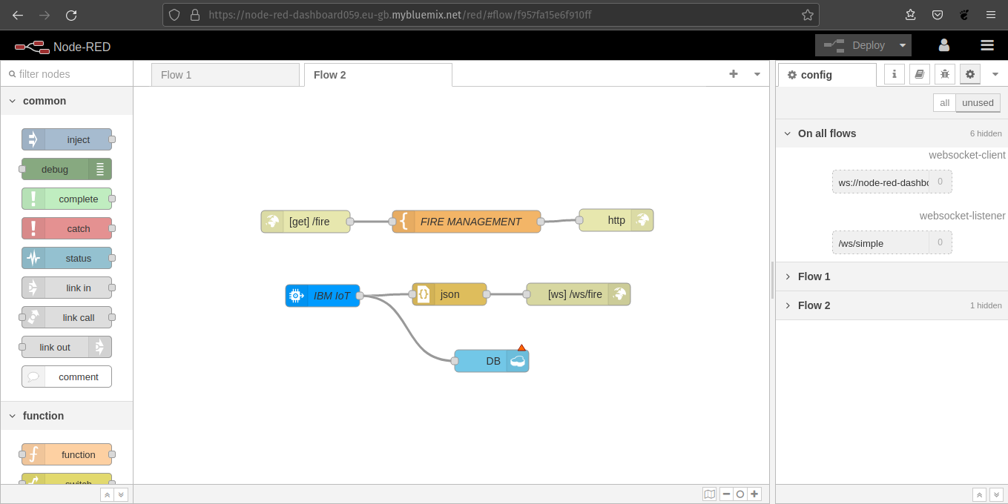

WEB UI:

DESKTOP VIEW

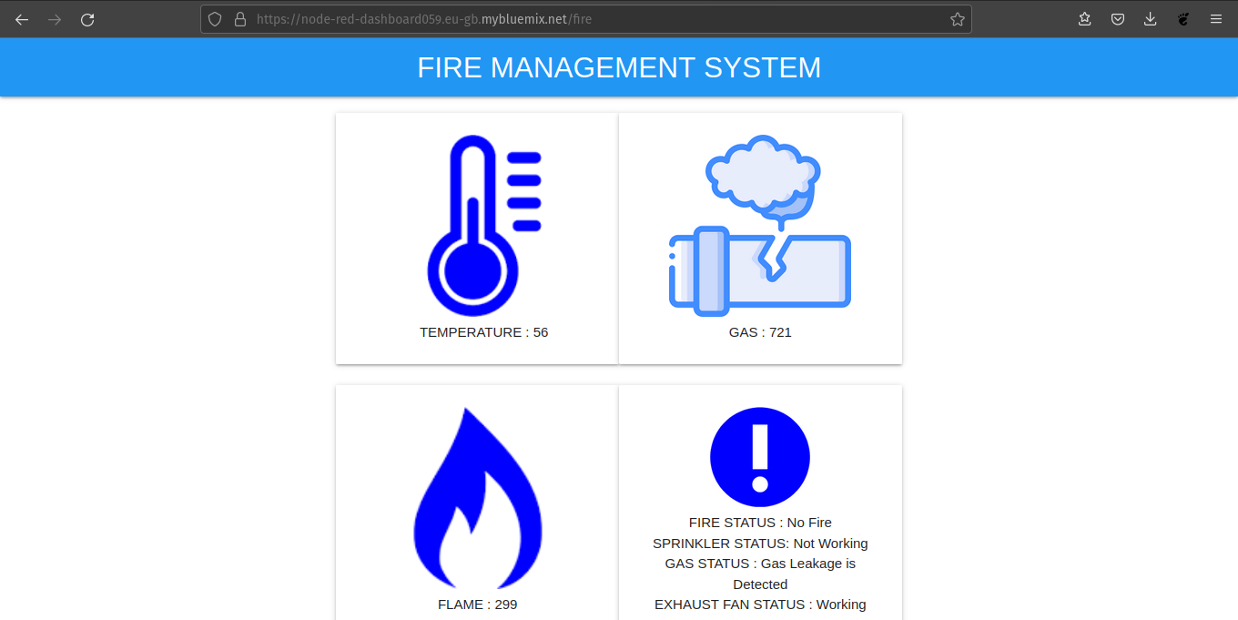

MOBILE VIEW:

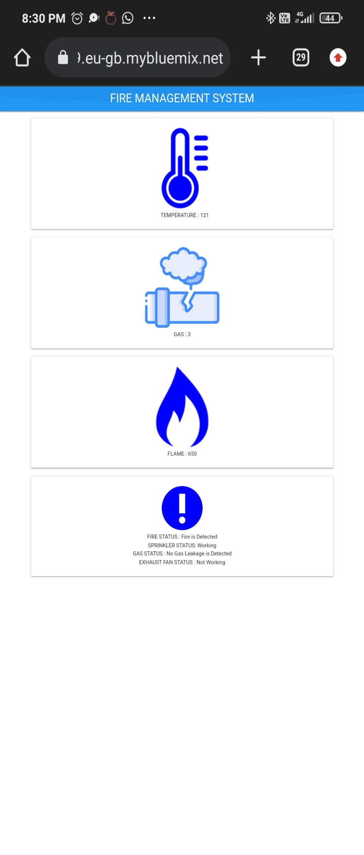

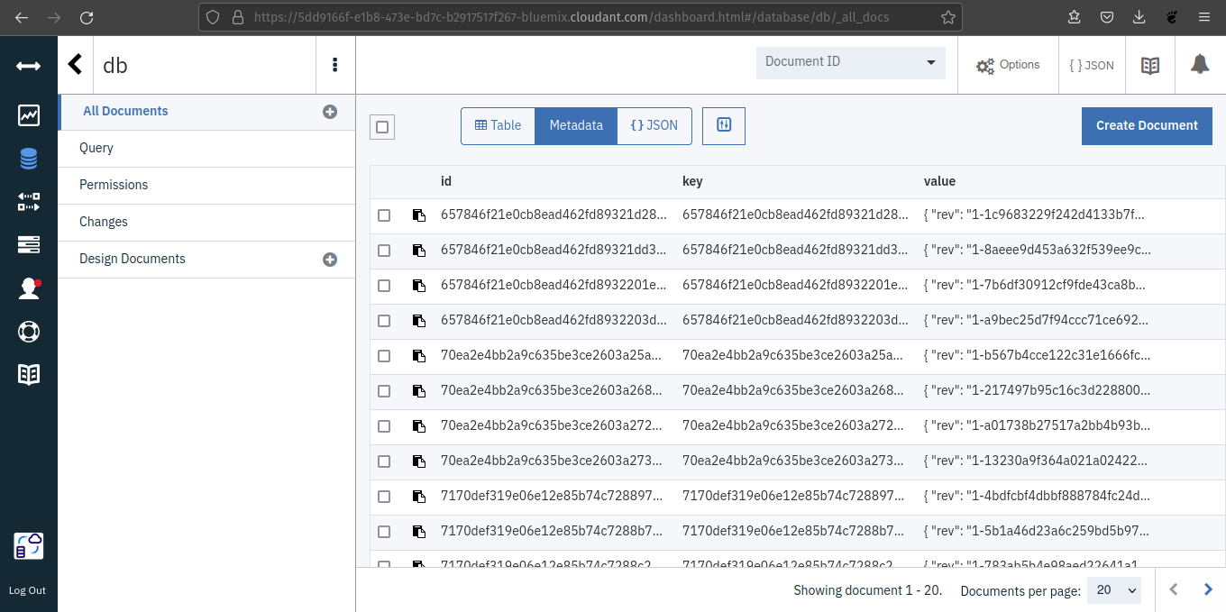CLOUDANT:

